1. Change the working directory to Friendly and use pluma from the command line to create A1.txt with the following personal information:

Name: <student name>

Email: <email id>

 Id: <student id>

Date: <date>

ii)                  Exit pluma and copy the new file A1.txt to B1.txt. Verify that both files exist by listing the directory.

iii)                Rename the B1.txt file to A.txt, then list the directory, and remove the A1.txt file, and list the directory again.

iv)                Set A.txt to have read and write permission for the owner, but keep the file private from others.

v)                  Now check the file permission for A.txt

vi)                Move to your home directory

vii)              Recursively list all the directories you have created

viii)            Show the tree structure and draw this.

2. **date** command and **cal** Command

i)                    Display 3 months from now.

ii)                  Display Monday as the first day.

iii)                Display September of 1752

iv)                Display 3 months for the date 9th March 2015

v)                  Display day of this week.

vi)                Display week number of the year

vii)              Display Date on this format - 12th April 1998

viii)            Display Date on this format - 12th Jan'95

ix)                Display Date on this format – 05/07/98

1. Display current date with hour minute second.

OUTPUT :

1. 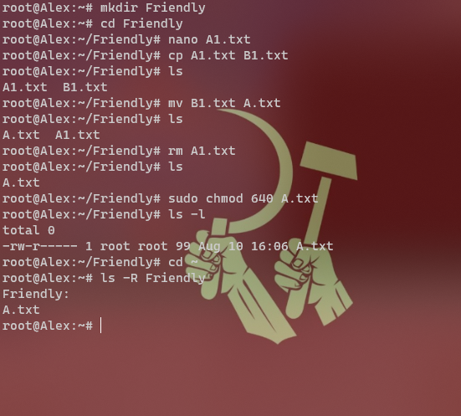

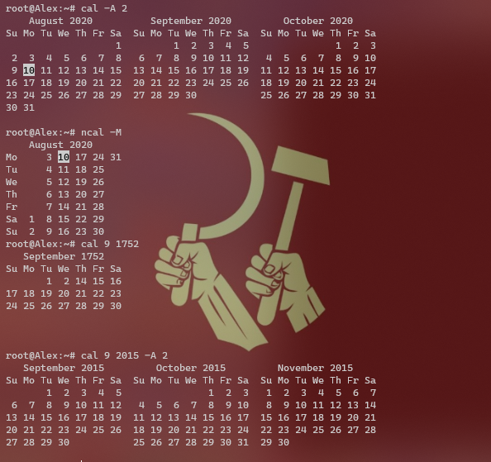

Continuation of 2 and 3 :

